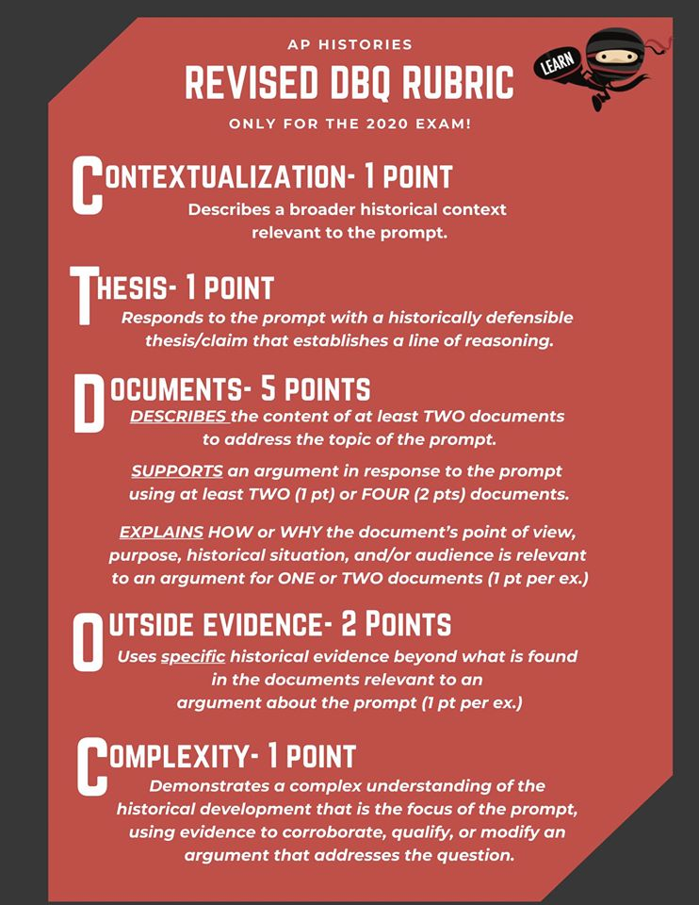
Question: Using your knowledge of world history and the documents, analyze the motivations for the exploration and colonization of the New World.

Document 1

Source: Map of the Columbian Exchange (https://sites.google.com/site/almasexplorationproject/the-columbian-exchange-and-the-triangular-trade)

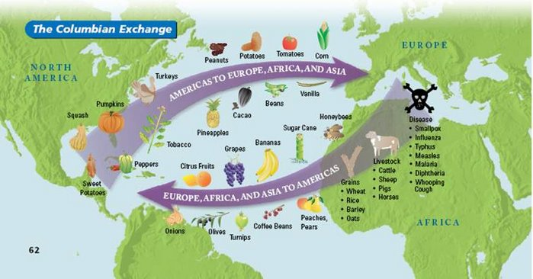

Document 2

Source: Christopher Columbus, Italian explorer, navigator, and colonizer, Letter to Doña Juana de Torres, October 1500

I should be judged as a captain who went from Spain to the Indies to conquer a people numerous and warlike, whose manners and religion are very different from ours, who live in sierras and mountains, without fixed settlements, and where by divine will I have placed under the sovereignty of the King and Queen our Lords, an Other World, whereby Spain, which was reckoned poor, is become the richest of countries

Document 3
Source: Bartoleme de Las Casas, Spanish historian and Dominican priest, Brief Account of the Devastation of the Indies. (1542)
Their reason for killing and destroying such an infinite number of souls is that the Christians have an ultimate aim, which is to acquire gold, and to swell themselves with riches in a very brief time and thus rise to a high estate disproportionate to their merits. It should be kept in mind that their insatiable greed and ambition, the greatest ever seen in the world, is the cause of their villainies. And also, those lands are so rich and felicitous, the native peoples so meek and patient, so easy to subject, that our Spaniards have no more consideration for them than beasts.

Document 4
Source: A French Jesuit Missionary, 1642
To make a Christian out of a Barbarian is not the work of a day. . . . A great step is gained when one has learned to know those with whom he has to deal; has penetrated their thoughts; has adapted himself to their language, their customs, and their manner of living; and when necessary, has been a Barbarian with them, in order to win them over to Jesus Christ.

Document 5
Source: Thomas Harriot, Englishman on the expedition to Roanoke, A Briefe and True Report of the New Found Land of Virginia, 1588

SIR, seeing that the part of the World, which is between the Florida and the Cape Breton now named VIRGINIA, to the honor of your most sovereign Lady and Queen Elizabeth, has been discovered by your means. And great charges. And that your colony has been there established to your great honor and praise, and no lesser profit unto the common America, it can never be advisable for England to quit this trade, and leave it to any other nation.

