WORLD HISTORY

Question 1 (Document Based Question)
Required reading and writing time: 45 minutes

It is suggested that you spend 10-15 minutes reading the documents
and 30-35 minutes writing your response. Note: You may begin writing
your response before the reading period is over.

Directions: Question 1 is based on the accompanying five documents. The documents have been edited for the purpose of this exercise.

In your response you should do the following.

• Respond to the prompt with a historically defensible thesis or claim that establishes a line of reasoning.
• Describe a broader historical context relevant to the prompt.
• Support an argument in response to the prompt using at least four documents.
• Use two additional pieces of specific historical evidence (beyond that found in the documents) relevant to an argument about the prompt.
• For at least two documents, explain how or why the document’s point of view, purpose, historical situation, and/or audience is relevant to an argument.
• Use evidence to corroborate, qualify, or modify an argument that addresses the prompt.

1. Evaluate the extent to which Christian and Muslim attitudes towards merchants and wealth differed, from their origins until c. 1600.

Document 1

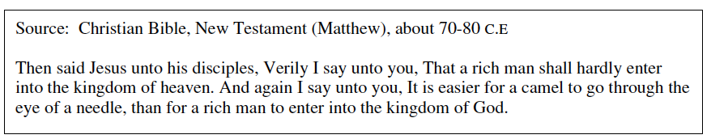

Document 2

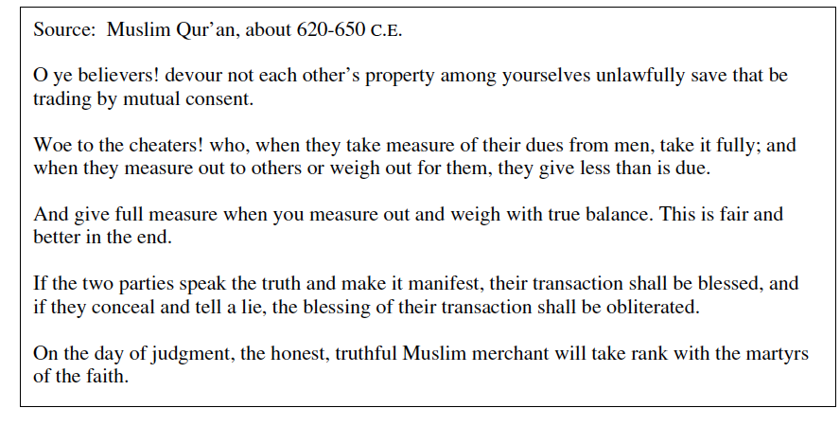

Document 3

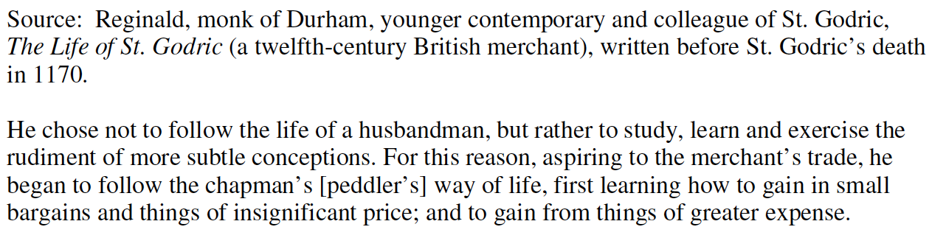
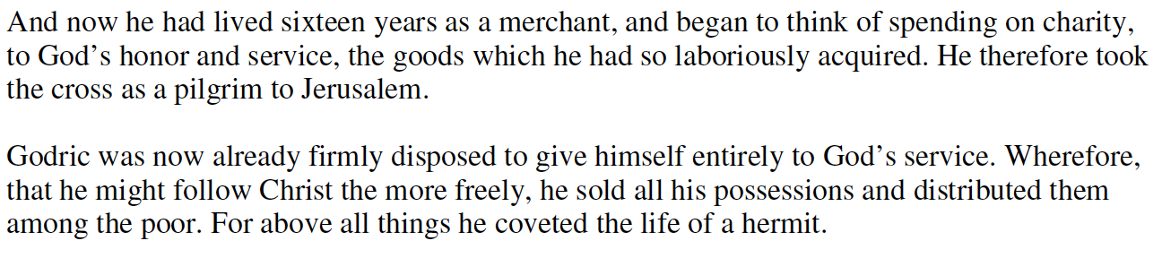

Document 4

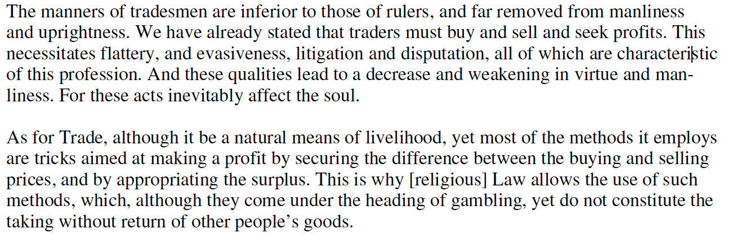

Document 5

Photograph : St. Peter’s Basilica, Rome, Italy…constructed 1506-1626

